## Problem 5 – DogeCoin

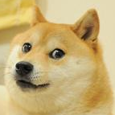Much coin, how money, such currency, so crypto. Wow.

Doge is a very popular dog. He is so popular that there is a crypto currency named after him. The crypto currency is named DogeCoin. Doge loves his DogeCoins and wants to gather as much as he can. Help this cute little animal.

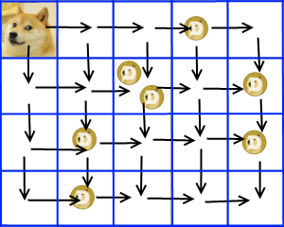Doge and the DogeCoins are placed on a **grid** consisting of **NxM cells** (**N vertical cells**, numbered from 0 to N-1 and **M horizontal cells**, numbered from 0 to M-1). Doge is always placed on location **[0; 0]**. Doge is **allowed** only to move in two directions (**right and down**).

There are **K** coins on the grid. Two or more coins may be on the same location. There also might be a coin(s) where Doge starts (0, 0) and he automatically gathers them.

Find the **biggest possible amount of coins** that Doge can gather when moving only down and right.

Wow.

### Input

The input data should be read from the console.

On the first line there will be the numbers **N** and **M**, separated by a single space.

On the second line there will be the number **K** – the number of the coins on the grid.

On the next **K** lines there will be the X and Y coordinates for each coin, separated by a space. **X** means the number of the row counting from 0 and **Y** means the number of the column, counting from 0 where the coin is located.

The input data will always be valid and in the format described. There is no need to check it explicitly.

### Output

The output should be printed on the console.

Output the biggest possible amount of coins that Doge can gather when moving only down and right.

### Constraints

* The numbers **N** and **M** will be non-negative integers between **1** and **2000**, inclusive.
* The number **K** will be a non-negative integer between **0** and **100000**.
* The coordinates of the coins will always be within the given grid.
* Allowed working time for your program: **0.2 seconds**.
* Allowed memory: **64 MB**.

### Examples

|  |  |  |  |  |  |  |  |
| --- | --- | --- | --- | --- | --- | --- | --- |
| **Input** | **Output** |  | **Input** | **Output** |  | **Input** | **Output** |
| 4 5  7  1 4  0 3  1 2  2 1  3 1  1 2  2 4 | 4  // See the  // picture  // above | 10 10  11  0 0  1 1  2 2  3 3  4 4  5 5  6 6  7 7  8 8  8 9  9 9 | 11 | 4 4  11  1 1  2 1  1 2  2 1  3 3  0 3  3 0  3 1  3 3  1 1  1 0 | 8 |

**Wow.**